Example No 01:

Input:

using System;

namespace Abdullah_CP_Lab_08

{

class Program

{

static void Main(string[] args)

{

string[] days = { "Mon", "Tues", "wed", "Thurs"};

for (int j = 0; j<days.Length;j++)

{

Console.WriteLine("days{0} is {1}",j,days[j]);

}

}

}

}

Output:

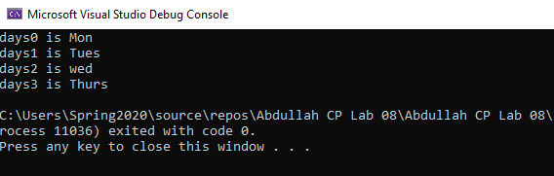

Example No 02:

Input:

using System;

namespace Abdullah_CP_Lab_08

{

class Program

{

static void Main(string[] args)

{

Console.Write("Enter a positive integer");

int n = int.Parse(Console.ReadLine());

int[] array = new int[n];

Console.WriteLine("Enter the value of the array:");

for (int i =0;i<n;i++)

{

array[i] = int.Parse(Console.ReadLine());

}

bool symmetric = true;

for (int i = 0; i<array.Length/2;i++)

{

if (array[i]!= array[n-i-1])

{

symmetric = false;

break;

}

}

Console.WriteLine("Is symmetric? {0}", symmetric);

}

}

}

Output:

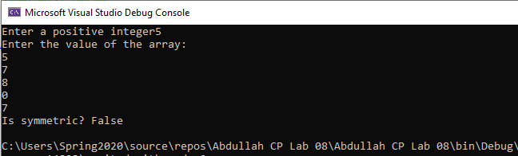

Task No 01: Write a program, which creates an array of 20 elements of type integer and initializes each of the elements with a value equal to the index of the element multiplied by 5. Print the elements to the console. Array [2] = 2*5

Input:

using System;

namespace CP_Lab_Tasks

{

class Program

{

static void Main(string[] args)

{

int[] array = new int[20];

for (int i = 0; i < array.Length; i++)

{

array[i] = i * 5;

Console.WriteLine(array[i]);

}

}

}

}

Output:

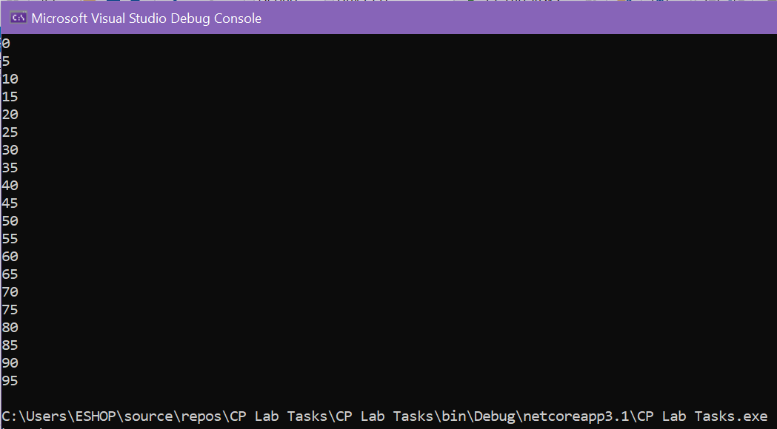

Task No 02: Write a program, which reads two arrays from the console and checks whether they are equal (two arrays are equal when they are of equal length and all their elements, which have the same index, are equal). Array [6] = {1,1,1,2,2,9} Array2 [6] = {1,1,1,2,2,2}

Input:

using System;

namespace CP_Lab_Tasks

{

class Program

{

static void Main(string[] args)

{

int n1, n2;

Console.Write("Enter the number of elements of array 1 : ");

n1 = int.Parse(Console.ReadLine());

Console.Write("Enter the number of elements of array 2 : ");

n2 = int.Parse(Console.ReadLine());

if (n1 == n2)

{

int[] arr1 = new int[n1];

Console.WriteLine("\nEnter the elements of array 1\n");

for (int i = 0; i < n1; i++)

{

Console.Write("Enter the value {0} : ", i + 1);

arr1[i] = int.Parse(Console.ReadLine());

}

int[] arr2 = new int[n2];

Console.WriteLine("\nEnter the elements of array 2\n");

for (int j = 0; j < n2; j++)

{

Console.Write("Enter the value {0} : ", j + 1);

arr2[j] = int.Parse(Console.ReadLine());

}

for (int i = 0; i < n1; i++)

{

arr1[i] = arr2[i];

if (arr1[i] == arr2[i])

{

Console.WriteLine("The Arrays are equal");

break;

}

else

{

Console.WriteLine("The lenght of the array is equal but values inside the array are unequal hence the array is not equal");

}

}

}

else

{

Console.WriteLine("The Arrays are not equal");

}

}

}

}

Output:

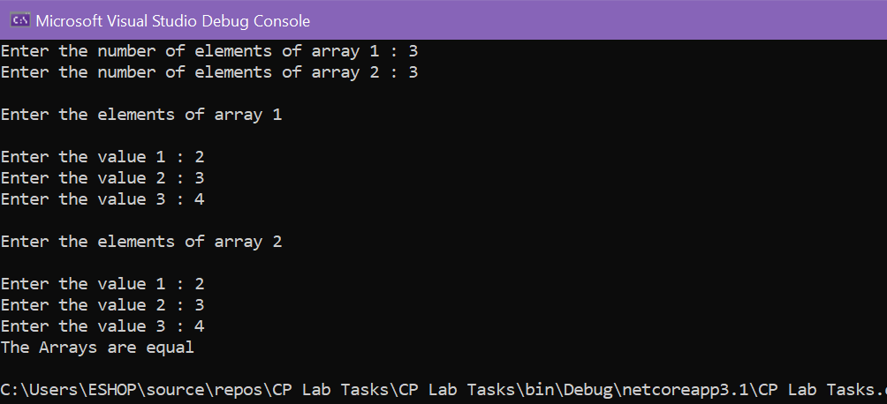

Task No 03: Make a program in C# in which take 5 numbers from user and then give sum and avg. of them. Using arrays.

Input:

using System;

namespace CP_Lab_Tasks

{

class Program

{

static void Main(string[] args)

{

double sum = 0;

double avg;

double[] arr = new double[5];

Console.WriteLine("Enter the five numbers");

for (int i = 0; i < arr.Length; i++)

{

arr[i] = double.Parse(Console.ReadLine());

sum = sum + arr[i];

}

Console.WriteLine("Sum of the arrays = " + sum);

avg = sum / 5;

Console.WriteLine("Average of the arrays = " + avg);

}

}

}

Output:

